LUIS SALAS

VISUAL PROMPT STUDIO 1.1

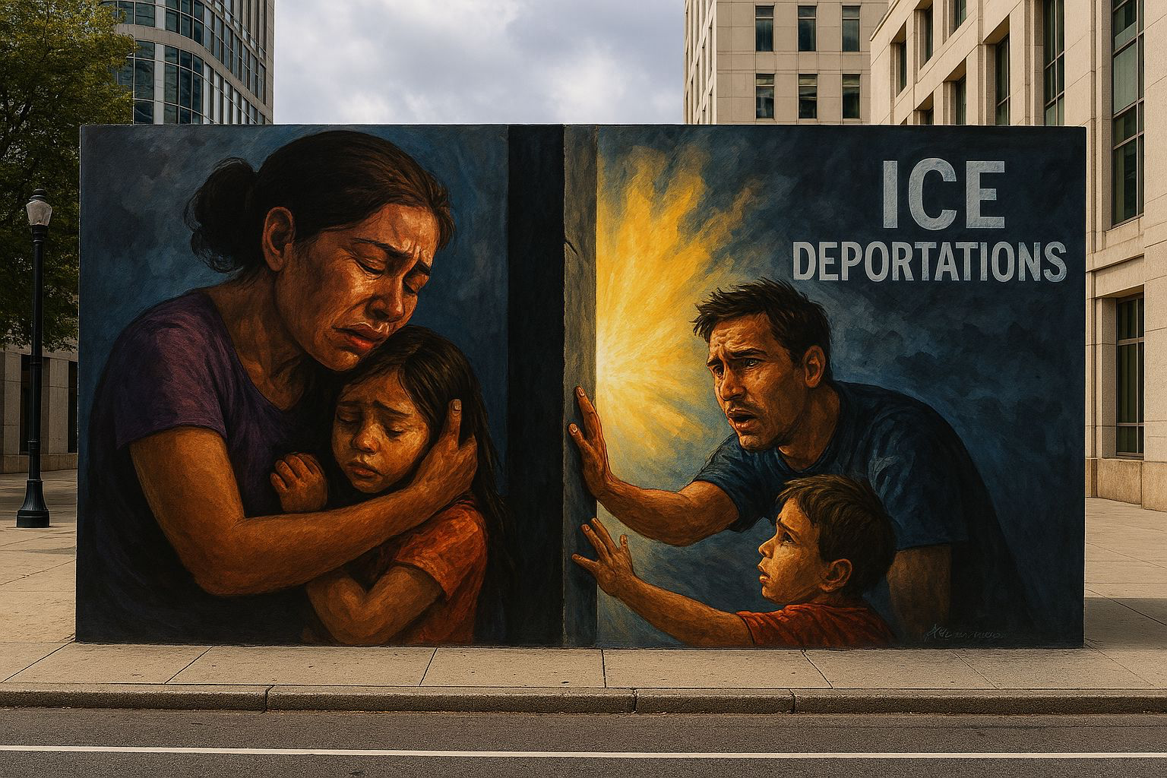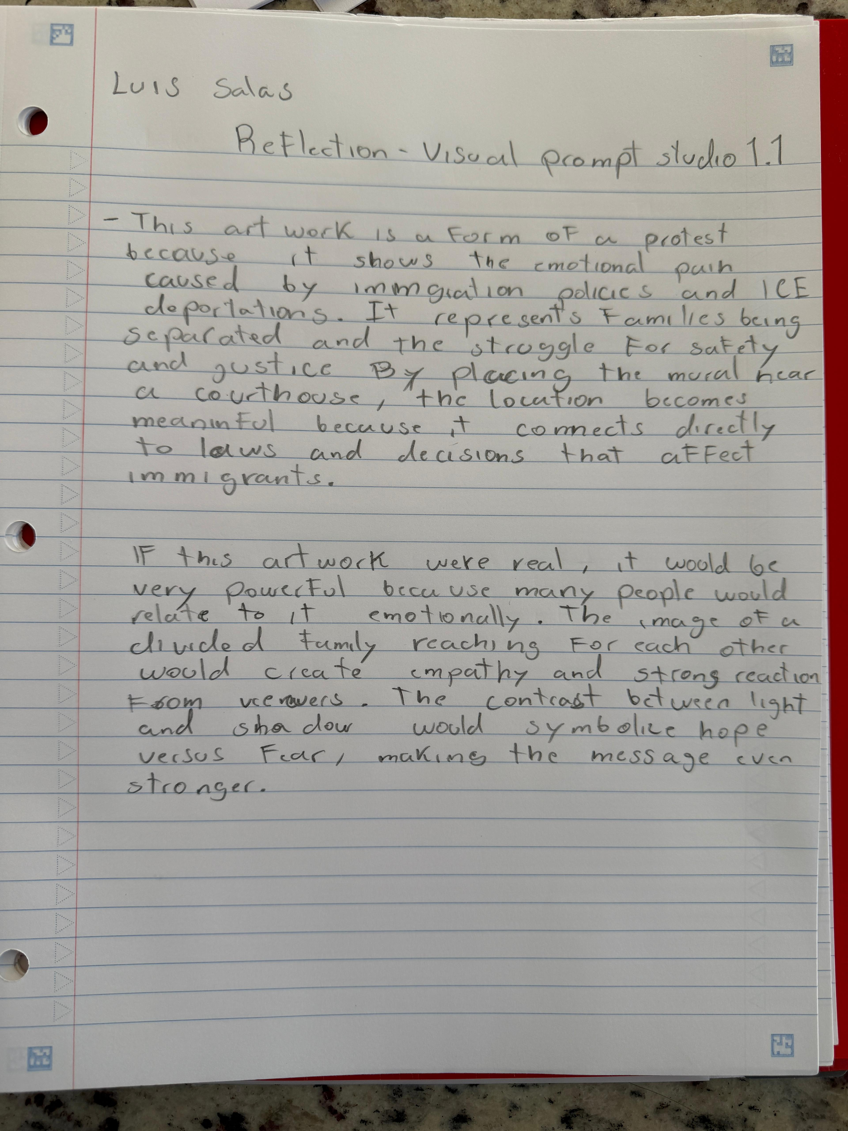Create a large-scale mural painted in acrylic on a public city wall near a downtown courthouse, designed as a form of social protest about immigration and ICE deportations. The artwork should inspire public discussion and raise awareness about family separation and human rights. Its meaning is to highlight the emotional pain caused by deportations and the hope for unity and justice. The subject matter includes a divided family reaching toward each other through a wall, with a bright light in the background symbolizing hope. The style should be representational with strong emotional expressions and dramatic contrast between light and shadow.